**How to Use the Code Editor**

1. Select the "Run Code" button to execute the program.
2. Select the "Calculate Grade" button to generate a score based on the completed tasks.
3. Continue to modify, run, and calculate your code until you are happy with the grade.
4. Select the "Submit" button to turn in the assignment to your instructor. Complete the coding activity. Your instructor will grade this activity manually.

**How to Use the Code Editor**

1. Select on the "Run Code" button to execute the program.
2. Make any necessary modifications to the code.
3. Continue to modify and run your code until you are happy with the output.
4. Select the "Submit" button to turn in the assignment to your instructor.

**Summary**

Alison has created another page for the Tri and Succeed Sports website providing biographies of the coaches at the club. She has already written the page content, acquired image files, and created a style sheet for the page layout. She wants you to finish the design of the page by developing a style sheet for the page’s color scheme and typography. A preview of the page you’ll design is shown in *Figure 2–58*.

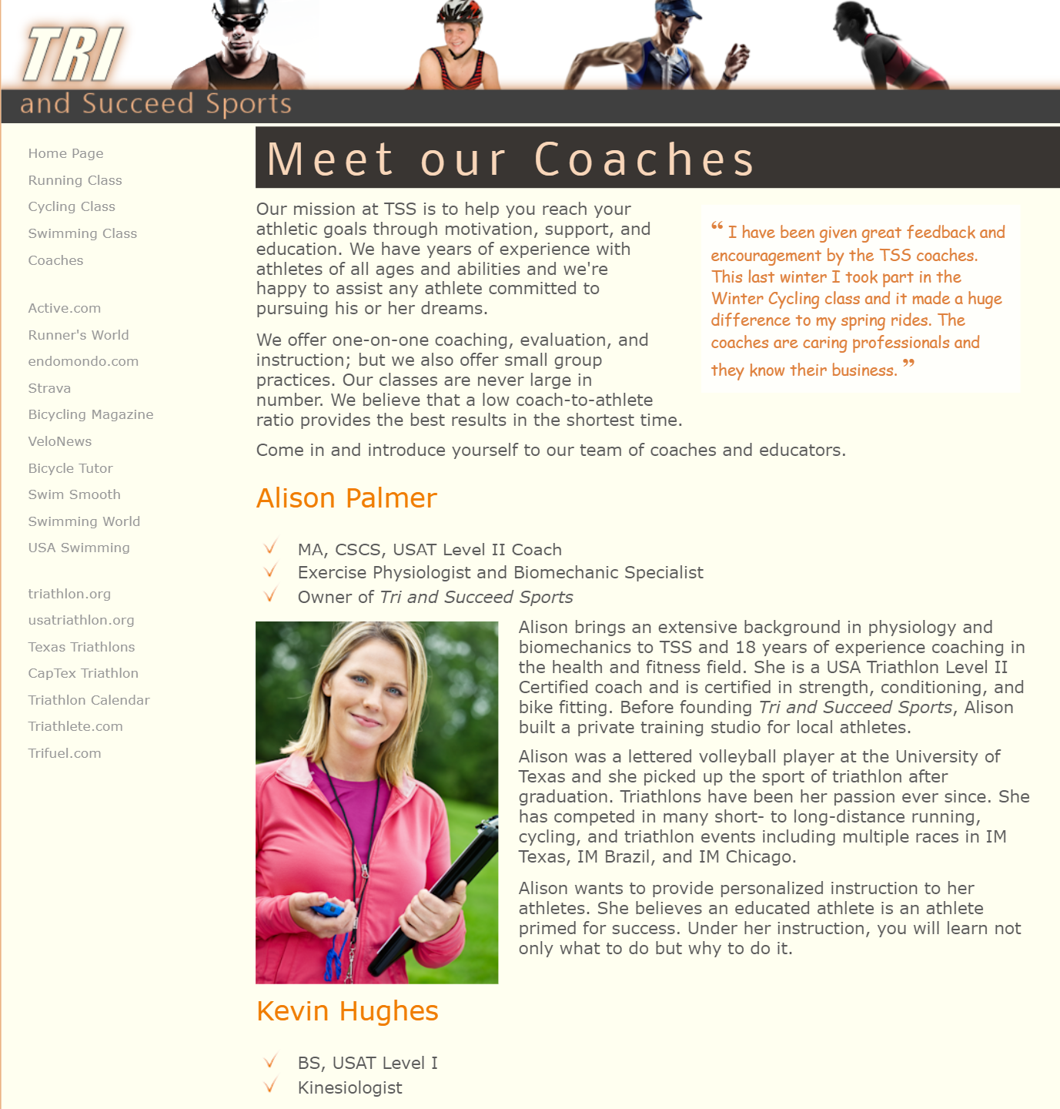 *Figure 2-58*

This is image does not represent the entire webpage.

**Document Setup**

Open the *tss_coach.html* and *coach_styles.css* files and enter your **name** and the **date** in the comment section of each file.

Next, go to the *tss_coach.html* file and within the document head, create links to the *coach_layout.css* and *coach_styles.css* style sheets.

Close the *tss_coach.html* file and open the *coach_styles.css* file and at the top of the file and before the comment section do the following:

1. Insert an @charset rule to set the character encoding for the file to utf-8.
2. Use the @font-face rule to define a web font named **Nobile**, which is based on the *nobile-webfont.woff* file and, if that format is not supported, on the *nobile-webfont.ttf* file.

**Main Structural Styles**

Go to the "Main Structural Styles" section in the *coach_styles.css* file and do the following:

1. Change the background color of the browser window by creating a style rule for the html element that sets the background color to the value **hsl(27, 72%, 72%)**.
2. For the body element, create a style rule to set the text color to the value **rgb(91, 91, 91)**, the background color to **ivory**, and body text to the font stack: **Verdana**, **Geneva**, **sans-serif**.

Create a style rule for the body > footer address selector containing the following styles:

1. The background color set to the value **rgb(222, 128, 60)**.
2. The font color to **white** and then to the semi-transparent value **rgba(255, 255, 255, 0.6)**.
3. The font style to **normal** displayed in bold small capital letters with a font size of **0.9em** and a line height of **3em** using the font stack: **Nobile**, **Verdana**, **Geneva**, **sans-serif**.
4. The text horizontally centered on the page.

**Heading Styles**

Go to the "Heading Styles" section and create a style rule for every h1 heading that displays the text with a **normal** font weight from the font stack: **Nobile**, **Verdana**, **Geneva**, **sans-serif**. Set the letter spacing to **0.2em** and the margins to **0** pixels.

Alison wants you to format the main h1 heading at the top of the page. Create a style rule for the section#tss_coaches h1 selector that sets the font size to **2.5em** with a color value of **hsl(27, 82%, 85%)** and background color of **hsl(27, 6%, 21%)**. Set the left padding space to **10** pixels.

Alison also wants you to format the h2 headings for each coach. Create a style rule for the article.coach_bio h2 selector that sets the font size to **1.6em** with **normal** weight and the font color to **rgb(240, 125, 0)**.

**Blockquote Styles**

Alison has inserted a comment from an athlete about the coaches. Format this comment by going to the "Blockquote Style" section and creating a style rule for the aside blockquote selector to do the following:

1. Set the font size to **0.95em** using the font stack: **‘Comic Sans MS’**, **cursive**.
2. Set the font color to **rgb(222, 128, 60)** and use a semi-transparent background color with the value **rgba(255, 2555, 255, 0.75)**.
3. Set the padding space to **10** pixels. Define opening and closing quotes for the element using the Unicode character 201C and 201D respectively.

Format the appearance of the opening quotes by creating a style rule for the aside blockquote::before selector to write a boldfaced open quote before the block quote with the font size set to **1.6em** from the font stack: **‘Times New Roman’**, **Times**, **serif**.

Format the appearance of the closing quotes by creating a style rule for the aside blockquote::after selector to write a boldfaced close quote after the block quote with the font size once again set to **1.6em** from the font stack: **‘Times New Roman’**, **Times**, **serif**.

**Navigation Styles**

Next, you’ll format the appearance of the navigation list by going to the "Navigation Styles" section and creating a style rule for body > nav selector that sets the text of the navigation list in a **0.8em** font size with a line height of **2em**.

Create a style rule for the nav > ul selector that removes the list marker and sets the left padding to **5** pixels.

Alison wants to break up the long list of links in the navigation list. Create style rules for the 6th and 16th li elements within the nav > ul selector that sets the size of the top margin of those items to **20** pixels.

For every previously visited or unvisited hypertext link within the nav > ul > li selector, set the text to the RGB color value **rgb(151, 151, 151)** and remove the underlining from the text link.

For every hovered or active hypertext link within the nav > ul > li selector, set the text color to RGB value **rgb(222, 128, 60)** and underline the hypertext link.

**Paragraph Styles**

Go to the "Paragraph Styles" section and insert a style rule that sets the top margin and bottom margin to **10** pixels, the right margin to **30** pixels, and the left margin to **0** pixels for every paragraph in the document.

**List Styles**

Every coach has a list of accomplishments. Go to the "List Styles" section and insert a style rule for the article.coach_bio > header > ul selector that displays the check.png file as the list marker and sets the margin space to **0** pixels, except for the bottom margin, which should be set to **10** pixels.

**Task 6**: When you have completed the assignment, check this task, open the task list and submit your work to your instructor.

**Task #01:** When you have completed the assignment, check this task and submit your work to your instructor.

RUN CODE

SUBMIT